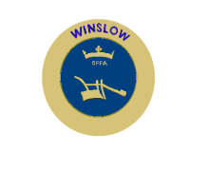

**WINSLOW TOWN COUNCIL**

**ENVIRONMENTAL POLICY**

The Town Council, in recognition of the 'climate emergency' commits to the following policies:

* to keep under review the management of its assets and operations so that, guided by mainstream scientific advice, it can identify practical steps towards sustainability, including the minimisation of its carbon footprint, and take those steps where practicable;
* to follow expert advice to maximise the biodiversity within Tomkins Park & Arboretum whilst preserving its recreational use; and maximise the biodiversity on other recreational land under the Council’s control and
* to engage with the residents of the Town, local organisations and the wider community to support relevant local initiatives that promote sustainable living and business practices and to improve the environment both within the Town and in the surrounding area.

May 2021